**Tabel Auth_Group**

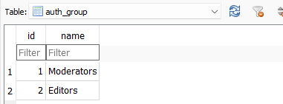

**Tabel Auth_Group_Permissions**

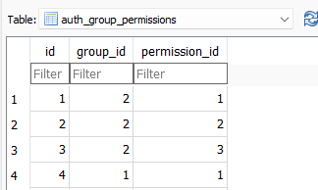

**Tabel Auth_Permission**

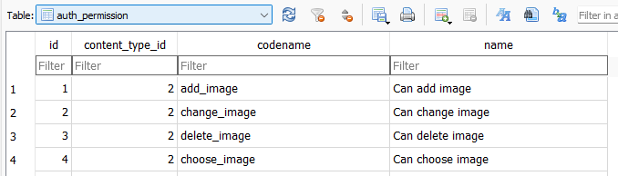

**Tabel Auth_User**

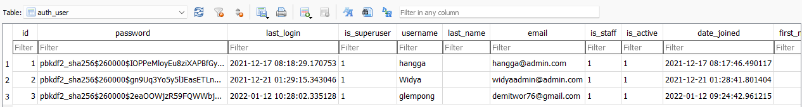

**Tabel Auth_User_Groups**

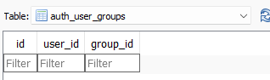

**Tabel Auth_User_User_Permissions**

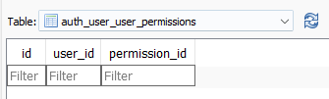

**Tabel Coderedcms_Adasettings**

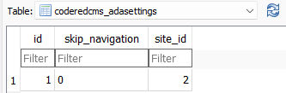

**Tabel Coderedcms_Analyticssettings**

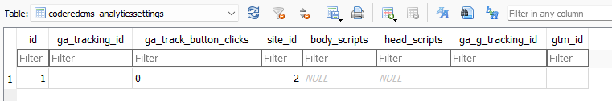

**Tabel Coderedcms_Carousel**

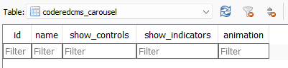

**Tabel Coderedcms_Carouselslide**

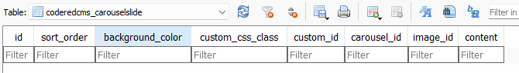

**Tabel Coderedcms_Classifier**

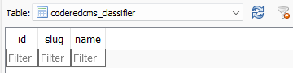

**Tabel Coderedcms_Classifierterm**

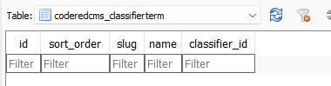

**Tabel Coderedcms_Coderedpage**

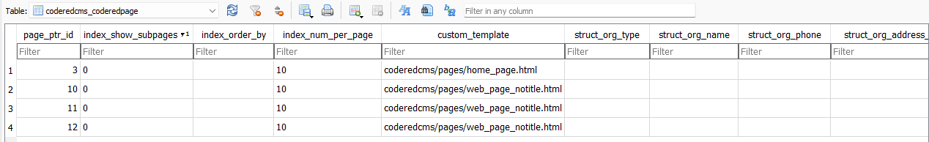

**Tabel Coderedcms_Coderedpage_Classifier_term**

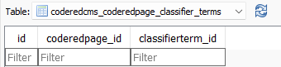

**Tabel Coderedcms_Coderedpage_Index_Classifiers**

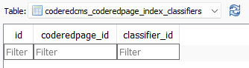

**Tabel Coderedcms_Coderedsessionformsubmission**

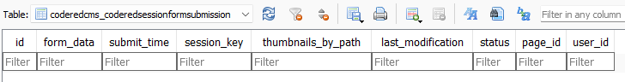

**Tabel Coderedcms_Coderedsubmissionrevision**

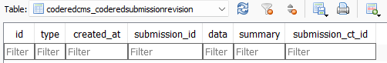

**Tabel Coderedcms_Coderedtag**

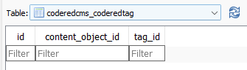

**Tabel Coderedcms_Contentwall**

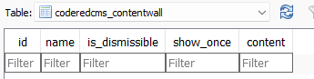

**Tabel Coderedcms_Footer**

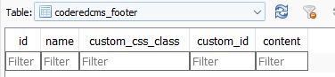

**Tabel Coderedcms_Generalsettings**

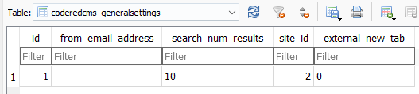

**Tabel Coderedcms_Googleapisettings**

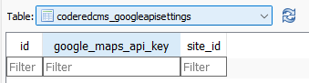

**Tabel Coderedcms_Layoutsettings**

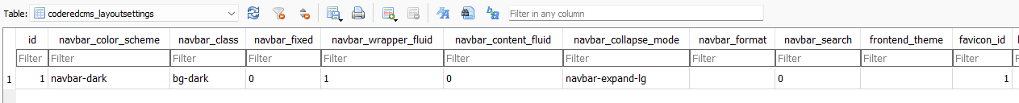

**Tabel Coderedcms_Mailchimpapisettings**

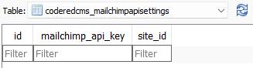

**Tabel Coderedcms_Navbar**

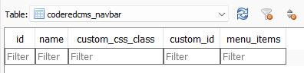

**Tabel Coderedcms_Reusablecontent**

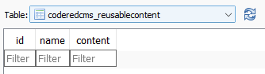

**Tabel Coderedcms_Socialmediasettings**

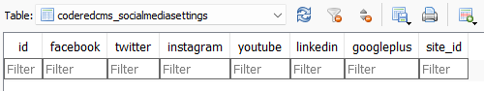

**Tabel Django_Admin_Log**

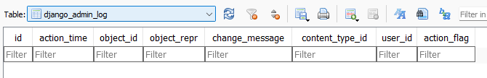

**Tabel Django_Content_Type**

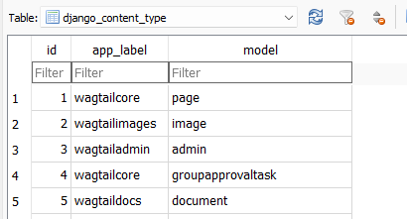

**Table Django_Migrations**

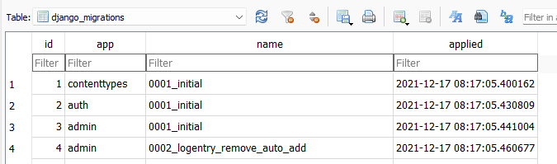

**Tabel Django_Session**

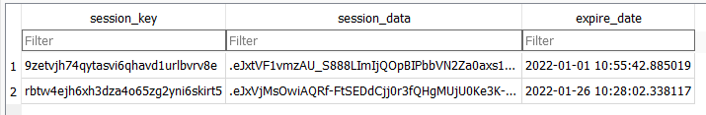

**Tabel Sqlite_Sequence**

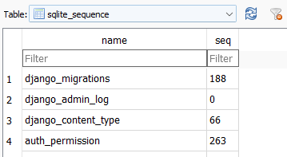

**Tabel Taggit_Tag**

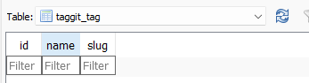

**Tabel Taggit_Taggeditem**

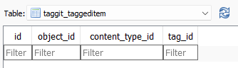

**Tabel Wagtailadmin_Admin**

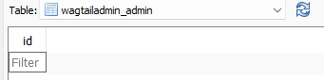

**Tabel Wagtailcore_Collection**

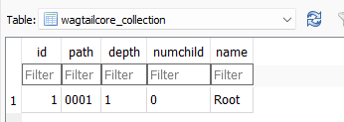

**Tabel Wagtailcore_Collectionviewrestriction**

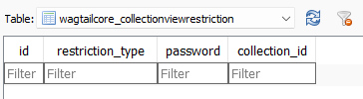

**Tabel Wagtailcore_Collectionviewrestriction_Groups**

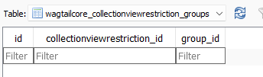

**Tabel Wagtailcore_Comment**

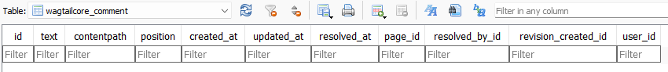

**Tabel Wagtailcore_Commentreply**

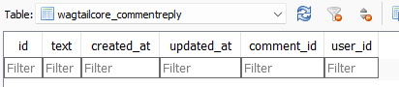

**Tabel Wagtailcore_Groupapprovaltask**

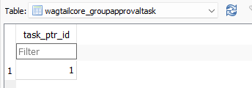

**Tabel Wagtailcore_Groupapprovaltask_Groups**

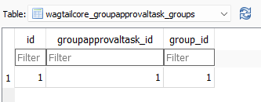

**Tabel Wagtailcore_Groupcollectionpermission**

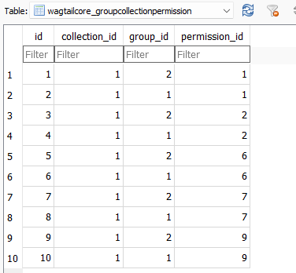

**Tabel Wagtailcore_Grouppagepermission**

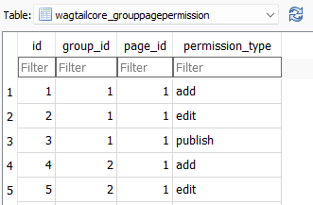

**Tabel Wagtailcore_Locale**

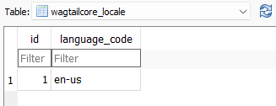

**Tabel Wagtailcore_Page**

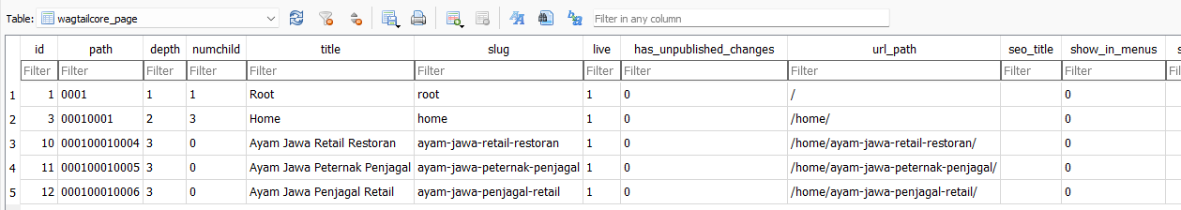

**Tabel Wagtailcore_Pagelogentry**

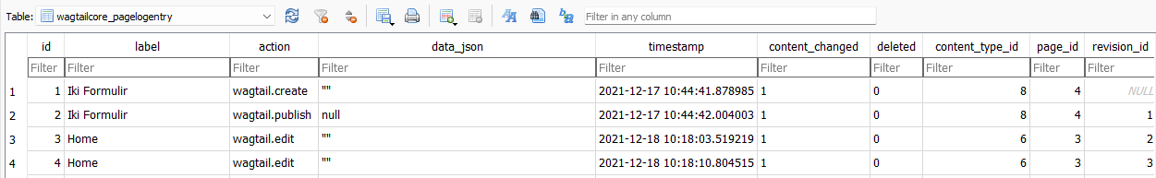

**Tabel Wagtailcore_Pagerevision**

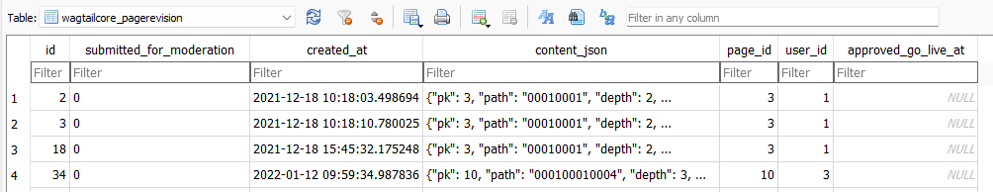

**Tabel Wagtailcore_Pagesubscription**

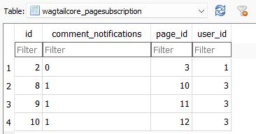

**Tabel Wagtailcore_Pageviewrestriction**

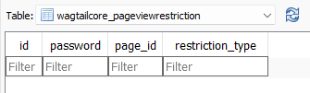

**Tabel Wagtailcore_Pageviewrestriction_Groups**

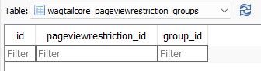

**Tabel Wagtailcore_Site**

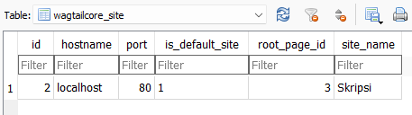

**Tabel Wagtailcore_Task**

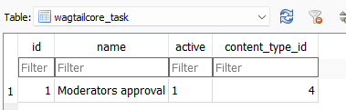

**Tabel Wagtailcore_Taskstate**

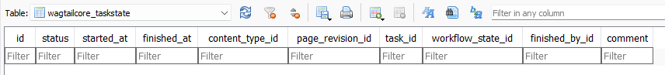

**Tabel Wagtailcore_Workflow**

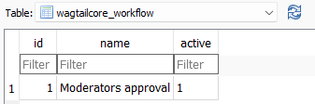

**Tabel Wagtailcore_Workflowpage**

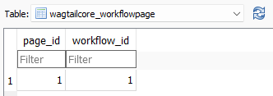

**Tabel Wagtailcore_Workflowstate**

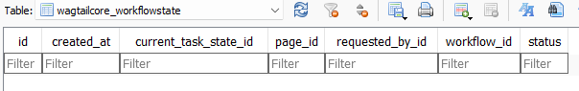

**Tabel Wagtailcore_Workflowtask**

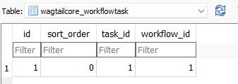

**Tabel Wagtaildocs_Document**

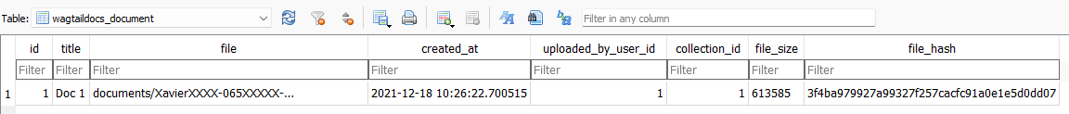

**Tabel Wagtaildocs_Uploadeddocument**

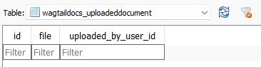

**Tabel Wagtailembeds_Embed**

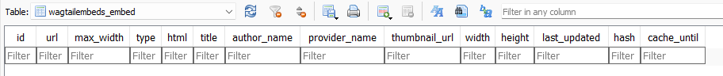

**Tabel Wagtailforms_Formsubmission**

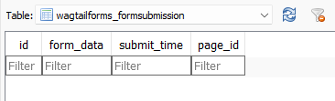

**Tabel Wagtailimages_Image**

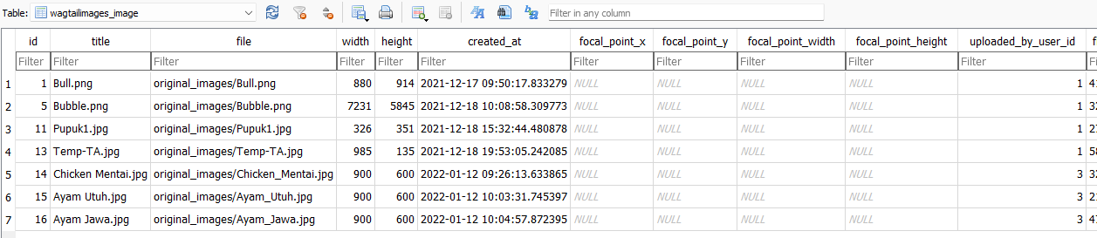

**Tabel Wagtailimages_Rendition**

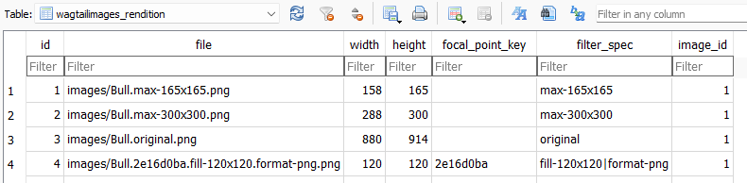

**Tabel Wagtailimages_Uploadedimage**

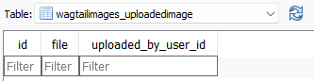

**Tabel Wagtailredirects_Redirect**

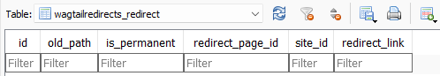

**Tabel Wagtailsearch_Editorspick**

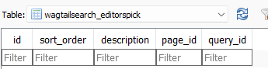

**Tabel Wagtailsearch_Query**

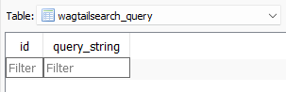

**Tabel Wagtailsearch_Querydailyhits**

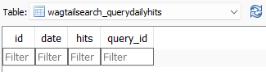

**Tabel Wagtailseo_Seosettings**

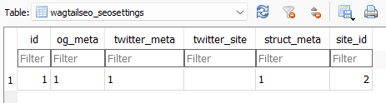

**Tabel Wagtailusers_Userprofile**

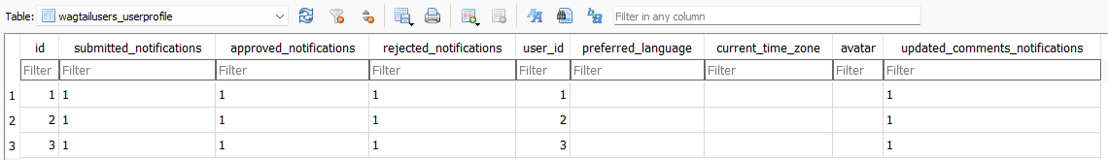

**Tabel Website_Articleindexpage**

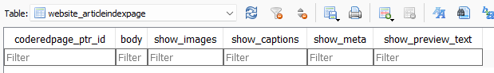

**Tabel Website_Articlepage**

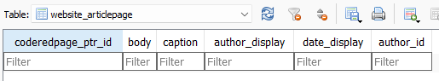

**Tabel Website_Formconfirmemail**

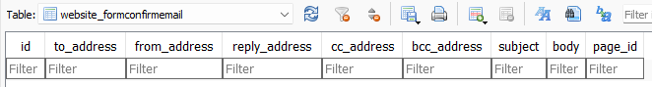

**Tabel Website_Formpage**



**Tabel Website_Formpagefield**

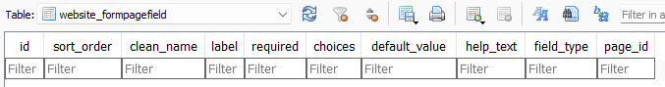

**Tabel Website_Webpage**

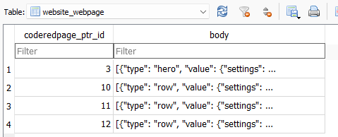

**Bapak juga bisa mengeksplor lebih jauh tabel diatas melalui tautan berikut**

https://github.com/hanggaa/Request